Robyn Sliva
Winner of the Swim Manitoba Sportsperson of the Year Award
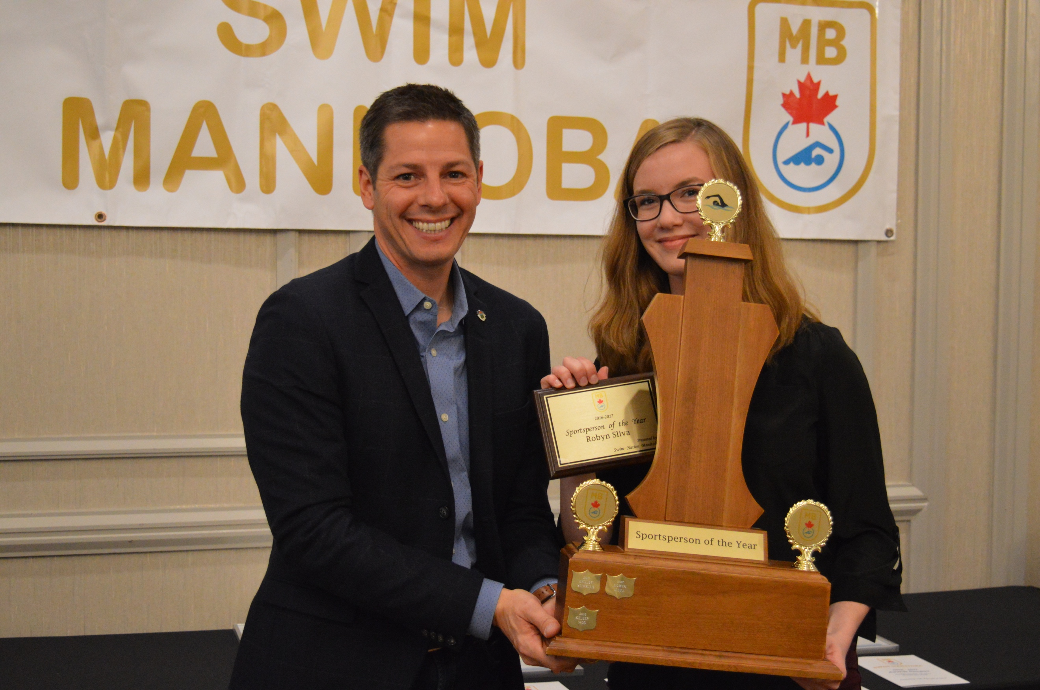
Excerpt from the nomination:
Robyn is a strong advocate of the benefits swimming provides both competitively and swimming for life. She is a dedicated swimmer that works hard at each practice focusing on the details she knows will help her make those important next steps. Para Swimming has a demanding schedule and requires a lot of shuffling to ensure everything is lined up. Her organizational skills ensure all is done at a high level of competency. Robyn has a determination for success both in and out of the pool and knows that you can only learn and improve when you are present, physically, emotionally and mentally. Robyn was selected by Swim Canada Coaches to partake in the NextGen Tokyo 2020 program. Robyn finds these camps very informative and returns to training with additional motivation, determination and attitude. Robyn was selected by Swim Canada to race on two relays last March at Can Am International Meet hosted by Windsor ON. Robyn helps out with her club’s younger swimmers that are not yet deep water safe, building strong bonds and creating an atmosphere of trust and mutual respect. Robyn’s strong community sense can be seen in her volunteerism. Robyn started in grade 9 volunteering at the community Library and within two years was selected to sit on the Library Youth Advisory Council for the City of Winnipeg. Robyn also volunteers for the United Way. In this position she is challenged to learn about and support women from other countries and cultures. Robyn graduated in June with honours with distinction and was awarded numerous scholarships including Swimming Matters Para Scholarship. She is now attending University of Manitoba Asper School of Business working on a commerce degree. Her long term goal is to pursue a Law Degree. Robyn exemplifies to all, what possibility truly means!
Your strength of character, your example of possibility and your unwavering commitment to your teammates, Para Storm is very proud of you. Congratulations Robyn!

