Vicky Scott & Robyn Sliva - Sport Manitoba Merit Award Winners
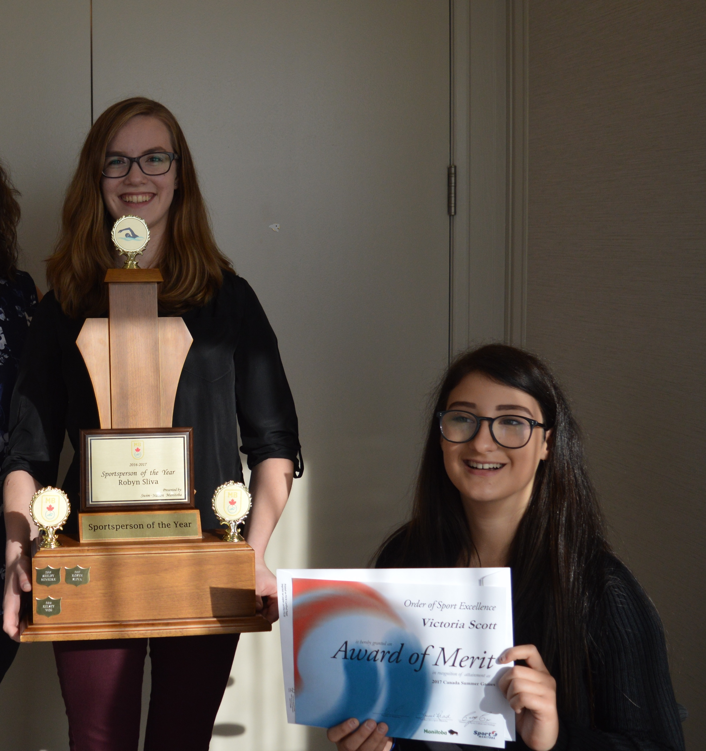

Vicky and Robyn received their Sport Manitoba Awards of Merit for Canada Summer Games along with their teammates and fellow Swim Manitoba award winners at the annual Swim MB Awards Banquet.
Congratulations Ladies, so excited & proud of you both!
